**Phase 1 – GanttProject**

**Decorator Pattern**

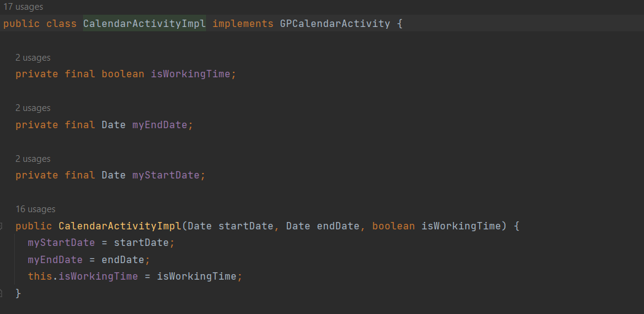

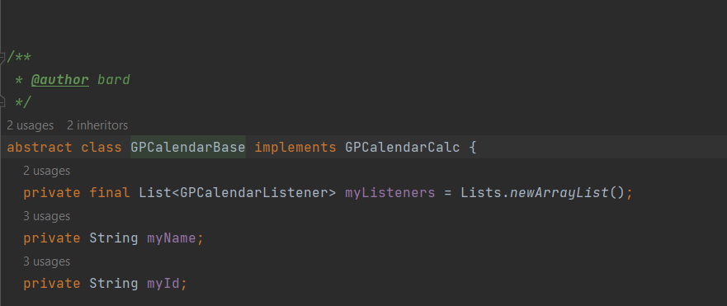

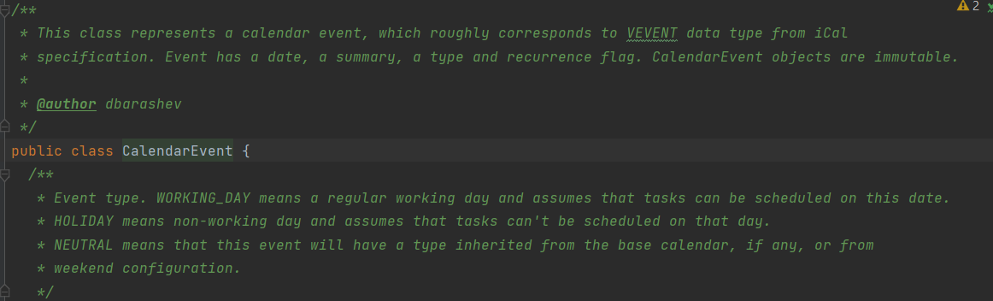

biz.ganttproject.core/src/main/java/biz.ganttproject/core/calendar

This is a Decorator design pattern because we have decorator classes, all with the same common type Calendar, that add their own behavior to a wrapped object.

* **Component interface:** GpcCalendar
* **Base object:** GpcCalendarBase
* **Decorators:** CalendarActivityImpl and CalendarEvent